kingdom of Saudi Arabia Ministry of Higher Education

Prince Sattam Bin Abdul-Aziz University College of Science and Humanitarian studies Computer Sciences Department

**المملكة العربية السعودية وزارة التعليم العالي**

**جامعة األمير سطام بن عبد العزيز كلية العلوم والدراسات اإلنسانية قسم علوم الحاسب**

Application for veterinary consulting system (TARAHUM)

|  |  |
| --- | --- |
| **N** | **STUDENT NAME** |
| **1** | **Nehal Ibrahim al-Zannan** |
| **2** | **Sawsan Tamim Al-Tamim** |
| **3** | **Wejdan Abdullah al-Hammad** |
| **4** | **Taghreed Shebeeb Al-Baker** |

## Supervised by:

Dr. Mohammed Alatiyyah

Department of Computer Science College of Sciences and Humanities Prince Sattam bin Abdul-Aziz University Al-Aflaj – Saudi Arabia

**December,2022-2023G - Jumada Al-Awwal,1444H**

kingdom of Saudi Arabia Ministry of Higher Education

Prince Sattam Bin Abdul-Aziz University College of Science and Humanitarian studies Computer Sciences Department

**المملكة العربية السعودية وزارة التعليم العالي**

**جامعة األمير سطام بن عبد العزيز كلية العلوم والدراسات اإلنسانية قسم علوم الحاسب**

Application for veterinary consulting system (TARAHUM)

**A Graduation Project Report Submitted to Sattam Bin Abdul-Aziz University for the Degree of Bachelor of Science in Computer Science**

|  |  |  |
| --- | --- | --- |
| **N** | **STUDENT NAME** | **STUDENT NUMBER** |
| **1** | **Nehal Ibrahim al-Zannan** | **441850170** |
| **2** | **Sawsan Tamim Al-Tamim** | **441850179** |
| **3** | **Wejdan Abdullah al-Hammad** | **441850217** |
| **4** | **Taghreed Shebeeb Al-Baker** | **441850425** |

## Supervised by:

Dr. Mohammed Alatiyyah

Department of Computer Science College of Sciences and Humanities Prince Sattam bin Abdul-Aziz University Al-Aflaj – Saudi Arabia

**December,2022-2023G - Jumada Al-Awwal,1444H**

**Abstract**

In general, there are many areas where there are no ways to help those interested in the field of animals or animal breeders, whether the assistance is immediate or not, especially in remote areas. Through this project, an application will be created for a veterinary system that aims to help those interested in animals or animal breeders to use the immediate veterinary consultation service and also the service of booking appointments with the veterinarian through linking with veterinary clinics.

**الملخص**

بشكل عام سنعمل على تطوير تطبيق يهدف إلى تحسين الوصول إلى الرعاية الصحية في المناطق النائية والمناطق التي تعاني من نقص في المرافق الطبية. يتيح التطبيق للأطباء والعيادات إنشاء حساباتهم الشخصية وعرض معلوماتهم، مما يسهل على المرضى البحث عنهم.

عند استخدام التطبيق، يمكن للمرضى تصفح العيادات والأطباء المتاحين وحجز مواعيد لزياراتهم أو طلب استشارات فورية. يمكن للمرضى والعيادات التواصل من خلال دردشة فورية، مما يسهل على المرضى الحصول على المشورة الطبية التي يحتاجونها بشكل سريع وموثوق.

هذا المشروع يهدف إلى تقديم حلاً مبتكرًا لتحسين خدمات الرعاية الصحية في المناطق التي تعاني من نقص في المرافق الطبية، مما يساهم في تحسين جودة الرعاية الصحية وزيادة إمكانية الوصول إليها في المملكة العربية السعودية.

.

##### Table of contents

Chapter 1: Intorduction 3

* 1. Introduction 4
  2. project objective 4
  3. project scope 4
  4. problem statement 5
  5. proposed solution 5
  6. Methodology 6
  7. project plan 7
  8. background 8
     1. Dartt 8
     2. Flutter 8
  9. conclusion 8

Chapter 2: Literature Review 9

* 1. Introduction 10
  2. proposed system 10
  3. Related Work 10
     1. Zoolker: 11
     2. PawSquad 12
     3. PetCoach 13
     4. VetCode 14
     5. Comparison table 15
  4. conclusion 15

Chapter 3: System Analysis 16

* 1. Introduction 17
  2. Actors role 17
  3. Functional requirement 18
  4. Non-Functional requirement 20
     1. Speed Response 20
     2. Security Requirements 20
     3. Usability Requirements 20
     4. Availability Requirements 21
  5. Conclusion 21

Chapter 4: System diagrams 22

* 1. Introduction 23
  2. Use case 23
     1. Use case diagram for Admin 24
     2. Use case diagrams for veterinarian 25
     3. Use case diagram for clinic 26
     4. Use case diagram for client 27
  3. Interaction Models (System Use Case) 28
     1. Log in 28
     2. Reset password 29
     3. Request Consultation 31
     4. Appointment Booking 32
  4. Class Diagram 34
     1. Class Diagram for Veterinary System 34
  5. ER Diagram 35
     1. ER Diagram for Veterinary System 35
  6. Database Schema 36
     1. Database Schema for Veterinary System 36
  7. Conclusion 37

Chapter 5: Summary 38

* 1. Summary 39
  2. References 40

**List of Figures**

**Figure 1-1: Waterfall Model****7**

**Figure 2-1: Zoolker application icon****11**

**Figure 2-2: PawSquad application icon****12**

**Figure 2-3: PetCoach application icon****13**

**Figure 2-4: VetCode application icon****14**

**Figure 4-1: Use case diagram for admin****24**

**Figure 4-2: Use case diagram for veterinarian****25**

**Figure 4-3: Use case diagram for clinic****26**

**Figure 4-4: Use case diagram for client****27**

**Figure 4-5: system use case for log in****28**

**Figure 4-6: sequence diagram for log in****29**

**Figure 4-7: system use case for Reset password****29**

**Figure 4-8: sequence diagram for Reset password****30**

**Figure 4-9: system use case for request consultation****31**

**Figure 4-10: sequence diagram for request consultation****32**

**Figure 4-11: system use case for Appointment Booking****32**

**Figure 4-12: sequence diagram for Appointment Booking****33**

**Figure 4-13: class diagram for veterinary system** **34**

**Figure 4-14: ER diagram for veterinary system** **35**

**Figure 4-15: database schema for veterinary system****…** **36**

**List of Tables**

**Table 1-1: project schedule****7**

**Table 2-1: Comparison table****15**

**Table 3-1: Actors' Role****17**

**Table 4-1: Interaction models: log in****28**

**Table 4-2: Interaction models: Reset password****30**

**Table 4-3: Interaction models: request consultation****31**

**Table 4-4: Interaction models: Appointment Booking****33**

# Chapter 1

### Introduction

#### Introduction

Technology is an important part of current life. Because it facilitates communication between people, and through the scientific development witnessed in the world and the interest in raising animals among most people, technology was introduced into the medical process for reasons including the lack of assistance from humans, especially in remote areas. The basic services in this project are providing immediate consultation in the event of a strange or sudden illness, and setting appointments with the veterinarian through linking with human clinics. This file is divided into five chapters. The first is a illustrative introduction to the application, while the second chapter presents the applications such as the one to be created. The third chapter explains the functional requirements for both users and the system and non-functional requirements. Chapter 4 contains ER diagram and drawings (UML). Finally, Chapter Five includes a summary of the report and references.

#### project objective

The main goal of this project is to design and implement a mobile application for the medical consultation system, where the customer can obtain medical advice through veterinarians who work around the clock and provide important advice and instructions to the customer, and the customer can also book an appointment to visit the doctor.

#### project scope

This project is a mobile application for medical services, founded in the year 2023 - 1444 AH, so its scope is intended for people in remote areas and all doctors and clinics in the Kingdom of Saudi Arabia.

#### problem statement

After conducting searches, the team noticed many problems that people were facing

If you are interested in untimely medical consultations, you will not find it easy to get a quick way to seek advice from a doctor. They also do not find it easy to book appointments at the clinic.

In addition, it is an application that allows people to communicate with the doctor quickly in emergency situations. This often happens in some areas where there are no private clinics for this type. Through this application, this feature will be provided in a quick way to communicate with the doctor and book clinic appointments with me.

#### proposed solution

It is a mobile application that helps patients in remote areas facilitate access to a doctor. The system allows those interested to register only by adding information (username, email, and password), and the system helps facilitate communication between the patient and the doctor through an instant chat in which the user requests questions and inquiries about a specific disease and an addition to receive assistance. It also allows displaying previous ratings, customer opinions, and adding a rating. The system also depends on the order, so that when choosing the services section, all choices related to the selected section are displayed. The system saves the user time and effort because it allows the user to request immediate consultation and book an appointment by sending the request and receiving a response to the request when the service is available to them.

#### Methodology

The waterfall model is one of the most widely used methodologies in the job market and is used in the field of software development. This methodology is simple and easy to understand and can be done once, as it is not possible to move to the next stage until after completing the previous one.

The waterfall model goes through five basic stages:

1. In the beginning, the work team will collect information and define requirements.
2. The second step is the system analysis, where the work team must identify the functional and non-functional requirements.
3. Then, in the third stage, which is the design stage, the program will be designed through appropriate diagrams for this project, such as class diagram, use case, ER diagram and database schema
4. After completing the design phase, the implementation and development phase comes, where the parts of the system are implemented correctly (writing codes).
5. Then the system must be tested so that we can register some clients in the application and make sure that it works properly.
6. If we find any errors in the system, we will maintain the system by fixing errors and updating the system.

**The following figure shows the systematic steps of the waterfall:** [1]

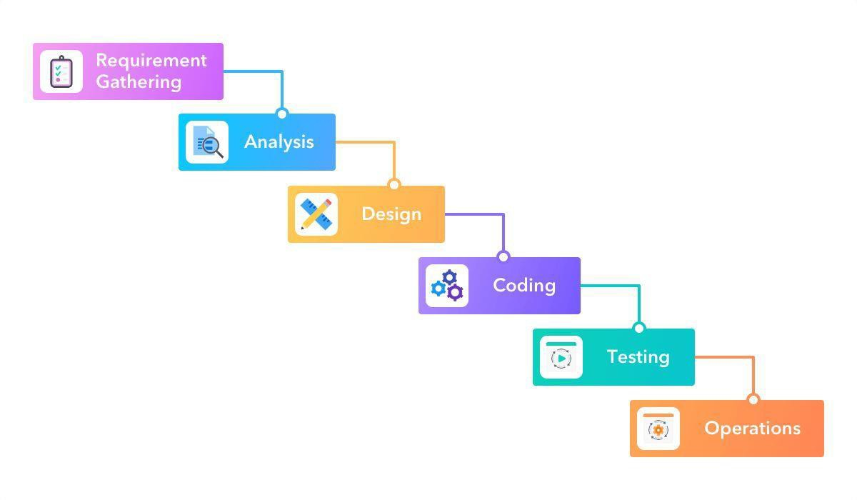

#### project plan

*Figure 1-1: Waterfall Model*

The following *Table 1-1* shows the division of assignments into semester weeks to complete this project according to a specific time plan:

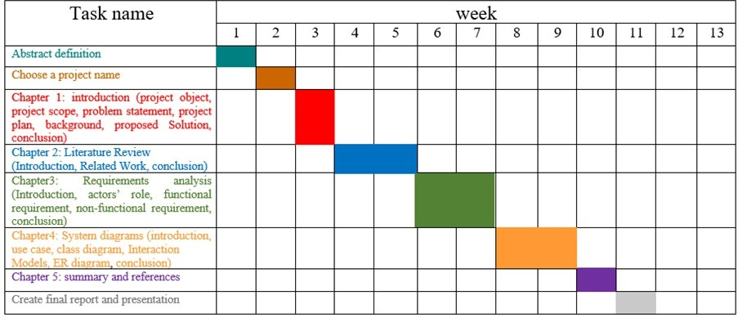

*Table 1-1: project schedule*

#### background

Information and experience that we must be able to master to do this work:

##### Dartt

It is a programming language designed for web development, Android applications, and the Apple platform. It is developed by Google, and it first appeared in 2011. It works on all advanced web platforms, mobile devices as well as web servers, and is close to programming languages. Others like Java, JavaScript, Kotlin, and others.

##### Flutter

The filters are (User Interface Tools), which is an open source program that provides a comprehensive framework in the (Dart) language, and helps to reduce time and effort and save money, and it is characterized by updating the programming language with one code that works in both platforms, and it helps programmers to design applications for all platforms with different screen sizes from Through the use of widgets are ready to facilitate the work.

## conclusion

In this chapter, a comprehensive overview of the project is presented, the objectives and scope of the project are defined, the motives for the project's work are determined, the work model followed, the time plan is determined through a Gantt chart to complete the work on time, and the programming language and program through which it will be done are clarified. Implementation of the application as well as proposed solutions.

# Chapter 2

### Literature Review

#### Introduction

In this chapter, we will talk about applications similar to the application that will be created and the similar advantages and disadvantages of each application, and in return the advantages that will be available in the application.

#### proposed system

This project aims to create and implement an application for medical services with advantages including: quick response, clear and uncomplicated request for service, and users can also benefit from previous experiences and advice of other users by viewing evaluations of clinics and veterinarians.

#### Related Work:

In this section, we will talk about the applications that are similar to our applications, and we will explore each application and its advantage and disadvantage.

#### Zoolker :



*Figure 2-1: Zoolker application icon*

It is an application that provides most of the services that make it easier for the breeder to deal with the animal, starting with accessories, food, and veterinary supplies. [2]

#### Advantages:

* + - * The method of displaying the services is explained in a clear section.
      * Easy to create an account in the application without problems.
      * speed Response.

#### Disadvantages:

* + - * Direct messaging is not available.
      * The absence of an evaluation for services.
      * Most of the services are written but unavailable and cannot be used at the present time.

#### PawSquad:



*Figure 2-2: PawSquad application icon*

It is an application for veterinary services, founded by Diwaker Singh and Radu Georgescu in 2015, the application allows pet owners to book an appointment with a veterinarian to visit the house or talk with veterinarians via video call or text chat.  [3]

#### Advantages:

* + - * Easy to use.
      * Speed Response.
      * The method of displaying the services is clear.
      * A file can create for the animal and add its full information during the request and the possibility of modifying it.

#### Disadvantages:

* + - * There is no evaluation of the veterinarian.
      * The application services cannot be browsed without logging in.
      * It is not possible to choose a specific doctor, the doctor is chosen randomly.

#### PetCoach :



*Figure 2-3: PetCoach application icon*

It is an application and website for asking veterinary questions online, which allows attaching a picture and adding text, and also allows those who specialize in this field to apply in the application as a veterinarian with features such as money and gain experience. It also allows adding an evaluation to the application. [4]

#### Advantages:

* + - * Three ways to log in.
      * There is a page to fill out the entire animal data.
      * There is an educator’s assessment of the app’s performance.

#### Disadvantages:

* + - * No direct contact with the doctor.
      * Depends only on subtraction.

#### VetCode:



*Figure 2-4: VetCode application icon*

It is an application that helps in choosing a veterinarian, gives advice to pet breeders, helps in buying and selling animals, and also enables a request for a veterinarian to examine the animal, and there is a service for vaccinations and required medicines. [5]

#### Advantages:

* + - * Browse the program without logging in .
      * easy to use.
      * Responsiveness speed.

#### Disadvantages:

* + - * The user cannot choose which doctor they want.
      * There are no ratings for the services.
      * Problems when logging in to request.
      * specific service, such as a vaccination service.
      * Wrong contact number and it doesn't work.

#### Comparison table

The following table shows a comparison between the previous applications and the application that will be created through five common characteristics selected from the advantages and disadvantages of each application:

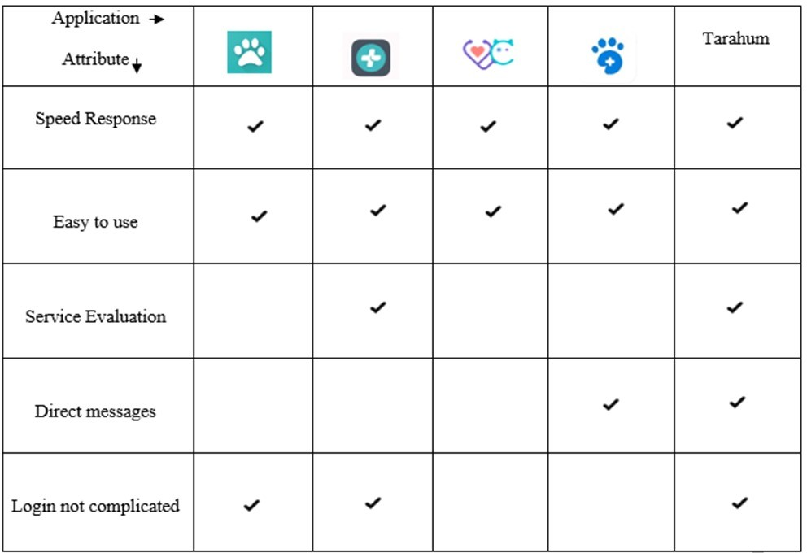

*table 2-1: Comparison table*

#### conclusion

In this chapter, we looked at some other applications similar to our application, in addition to collecting information about these applications to obtain a broader view, and identifying some of the disadvantages and advantages of the application from our view, and suggest some improvements to it.

# Chapter 3

### Requirements analysis

#### Introduction

In this chapter we will talk about the actors in the system and explain the role of each actor. We will mention the functional requirements of each user and the non-functional requirements of the system, and we will expand on the ease of use of the system, its response speed, availability feature, and the security methods used in the system.

#### Actors role

This section describes the system actors. An actor is an abstraction created in an IT system that a stakeholder uses to exchange data needed to complete use case actions; [6] so, the actors play specific roles in the use case as shown below:

|  |  |
| --- | --- |
| **ACTORS** | **ROLES** |
| **Admin** | The person who owns absolute privileges and fully  manages the application. |
| **Client** | The person who uses the application to communicate with the veterinarians and also can book an appointment at a clinic from the application. |
| **Veterinarian** | A person who provides veterinary medical consultations to client, and provides important  guidance to deal with the animal when needed. |
| **Clinic** | The role of the clinic in the system is to register and then make appointments available so that the client can choose the appropriate appointment for him and then receive him in the clinic and serve the client  according to his needs. |

*Table 3-1: Actors' Role*

#### Functional requirement

System features and functions that a system developer must implement to enable the user to use the system as required. In this system we have four representatives for each representative specific requirement.

1. **The admin**
2. **The client**
3. **The Veterinarian**
4. **The clinic**

In this section of the chapter table 3-2 detailed the requirements for each actor:

|  |  |  |  |  |
| --- | --- | --- | --- | --- |
| **Requirement** | **Admin** | **Clinic** | **Veterinarian** | **Client** |
| **Sing up:**  Ability to Sign up on the application, enter the data of the clinic. |  | صورة تحتوي على سهم  تم إنشاء الوصف تلقائياً | صورة تحتوي على سهم  تم إنشاء الوصف تلقائياً | صورة تحتوي على سهم  تم إنشاء الوصف تلقائياً |
| **Log in:**  Ability to log in to the application. | صورة تحتوي على سهم  تم إنشاء الوصف تلقائياً | صورة تحتوي على سهم  تم إنشاء الوصف تلقائياً | صورة تحتوي على سهم  تم إنشاء الوصف تلقائياً | صورة تحتوي على سهم  تم إنشاء الوصف تلقائياً |
| **Log out:**  Ability to log out to the application. | صورة تحتوي على سهم  تم إنشاء الوصف تلقائياً | صورة تحتوي على سهم  تم إنشاء الوصف تلقائياً | صورة تحتوي على سهم  تم إنشاء الوصف تلقائياً | صورة تحتوي على سهم  تم إنشاء الوصف تلقائياً |
| **Reset password:**  Ability to reset password when forgotten. | صورة تحتوي على سهم  تم إنشاء الوصف تلقائياً | صورة تحتوي على سهم  تم إنشاء الوصف تلقائياً | صورة تحتوي على سهم  تم إنشاء الوصف تلقائياً | صورة تحتوي على سهم  تم إنشاء الوصف تلقائياً |
| **Modify account:**  Ability to view and modify information | صورة تحتوي على سهم  تم إنشاء الوصف تلقائياً | صورة تحتوي على سهم  تم إنشاء الوصف تلقائياً | صورة تحتوي على سهم  تم إنشاء الوصف تلقائياً | صورة تحتوي على سهم  تم إنشاء الوصف تلقائياً |
| **Manage Veterinarians:**  Ability to view veterinarian information, accept or reject veterinarian, and delete veterinarian. | صورة تحتوي على سهم  تم إنشاء الوصف تلقائياً |  |  |  |
| **Manage section:**  Ability to view section, add section, delete section, and modify section. | صورة تحتوي على سهم  تم إنشاء الوصف تلقائياً |  |  |  |
| **Manage clinic:**  Ability to view clinic information, accept or reject clinic, delete clinic. | صورة تحتوي على سهم  تم إنشاء الوصف تلقائياً |  |  |  |
| **Manage notification:**  Ability to activate notification or close it. | صورة تحتوي على سهم  تم إنشاء الوصف تلقائياً | صورة تحتوي على سهم  تم إنشاء الوصف تلقائياً | صورة تحتوي على سهم  تم إنشاء الوصف تلقائياً | صورة تحتوي على سهم  تم إنشاء الوصف تلقائياً |
| **View clint information:**  Ability to View data for clint. | صورة تحتوي على سهم  تم إنشاء الوصف تلقائياً |  |  |  |

|  |  |  |  |  |
| --- | --- | --- | --- | --- |
| **Requirement** | **Admin** | **Clinic** | **Veterinarian** | **Client** |
| **Manage Requests Appointment:**  Ability to View Request Appointment, Confirm or cancel appointment |  | صورة تحتوي على سهم  تم إنشاء الوصف تلقائياً |  |  |
| **Schedule appointments:**  Ability to Add available time to receive clients. |  | صورة تحتوي على سهم  تم إنشاء الوصف تلقائياً |  |  |
| **View evaluation:**  Ability to View evaluation messages. |  | صورة تحتوي على سهم  تم إنشاء الوصف تلقائياً | صورة تحتوي على سهم  تم إنشاء الوصف تلقائياً |  |
| **Manage Requests Consultation:**  Ability to view Requests Consultation, accept or reject Request Consultation. |  |  | صورة تحتوي على سهم  تم إنشاء الوصف تلقائياً |  |
| **Chatting:**  Ability Start or End chat. |  |  | صورة تحتوي على سهم  تم إنشاء الوصف تلقائياً | صورة تحتوي على سهم  تم إنشاء الوصف تلقائياً |
| **Attach media:**  Ability to Attach photo, video and voice |  |  | صورة تحتوي على سهم  تم إنشاء الوصف تلقائياً | صورة تحتوي على سهم  تم إنشاء الوصف تلقائياً |
| **Request Consultation:**  Ability to send Request Consultation to any Veterinarian he choose. |  |  |  | صورة تحتوي على سهم  تم إنشاء الوصف تلقائياً |
| **Appointment booking:**  Ability to book an appointment any available time by the clinic he choose. |  |  |  | صورة تحتوي على سهم  تم إنشاء الوصف تلقائياً |
| **Modify appointment:**  Ability to Modify booking appointment time or cancel. |  |  |  | صورة تحتوي على سهم  تم إنشاء الوصف تلقائياً |
| **Browse section:**  Ability to View clinics, veterinarian and search box. |  |  |  | صورة تحتوي على سهم  تم إنشاء الوصف تلقائياً |
| **Manage evaluation:**  Ability to view veterinarian, clinic evaluations, and he can add veterinarian, clinic evaluation. |  |  |  | صورة تحتوي على سهم  تم إنشاء الوصف تلقائياً |

*Table 3-2: functional requirement*

#### Non-Functional requirement

In this section, we will talk about additional features of the system, such as speed response, security, ease of use and availability, which are requirements for the overall quality of the system. Non-functional requirements are often applied to the system as a whole rather than individual features or services in the system.

###### Speed Response

The Application must be downloaded and used within a reasonable time of not more than five seconds after any button is pressed. The application should refresh the interface on interaction with the lowest response time.

###### Security Requirements

The system must protect client data so that no one else can see it. Also, the administrator has full control over the system and can monitor requests, consultations, and accept or reject veterinarians. One common method of information security and privacy is an authorized access request using a username and password.

###### Usability Requirements

The application is easy to use by providing a notification feature for all actors, easy identification of distinguished clinics and veterinarians by providing a description and seeing previous client evaluations and opinions or adding a new evaluation for each of them, and ease of clients communication with the veterinarian and vice versa.

###### Availability Requirements

The system will be ready and available 24/7. The app will be available for Android devices.

#### Conclusion

In this chapter, we introduced the actors and their roles, we also presented the functional requirements and clarified a simplified explanation for each functional requirement and also presented the non-functional requirements that will be applied in the system and a detailed explanation for each non- functional requirement.

# Chapter 4

### System diagrams

#### Introduction

This chapter introduces the system design phase. At this stage, the system design will be created using UML diagrams, such as drawing use cases for all actors, and clarifying some operations using sequence diagrams and also drawing class diagrams and finally describing the system database drawn using ER diagram and database schema.

#### Use case

Describes the system from the user's point of view, that is, from the point of view of an external observer and does not go into the details of the system's work, leaving the details of the realization of each action to other schemes. So, use case diagrams focus on what the system does, not how it works. [7] Due to size of the use case elaborated for the intended system, we opted for presenting the use case per actor. There are 4 main actors in our system: admin, clinic, veterinarian, and client.

**Figure: 4.1, 4.2, 4.3, and 4.4 illustrates the 4 uses case proposed in this report:**

##### Use case diagram for Admin

The figure shows the steps taken by the manager, starting from entering the system, managing his personal account, displaying client information, managing veterinarians, managing the sections, managing the clinic, and managing notifications.

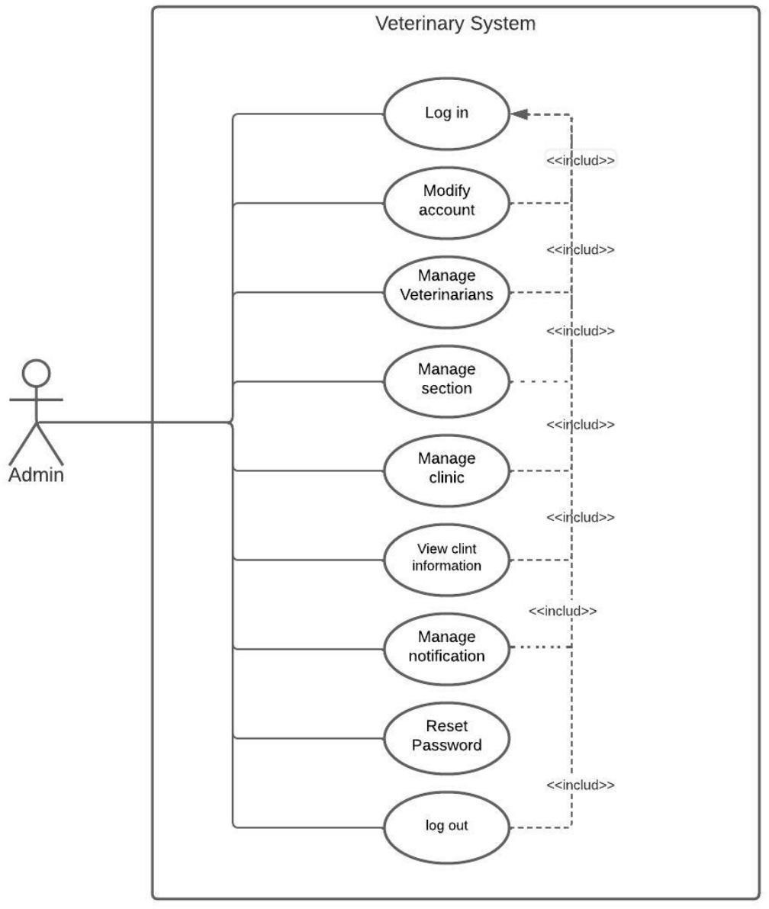

*Figure 4-1: Use case diagram for admin*

##### Use case diagrams for veterinarian

The use case diagram is used to give an overview of the veterinarian's system, starting from logging into the system, entering it, modifying the account, resetting the password, in addition to displaying consultation requests, chatting, attaching media, displaying the evaluation and managing notifications.

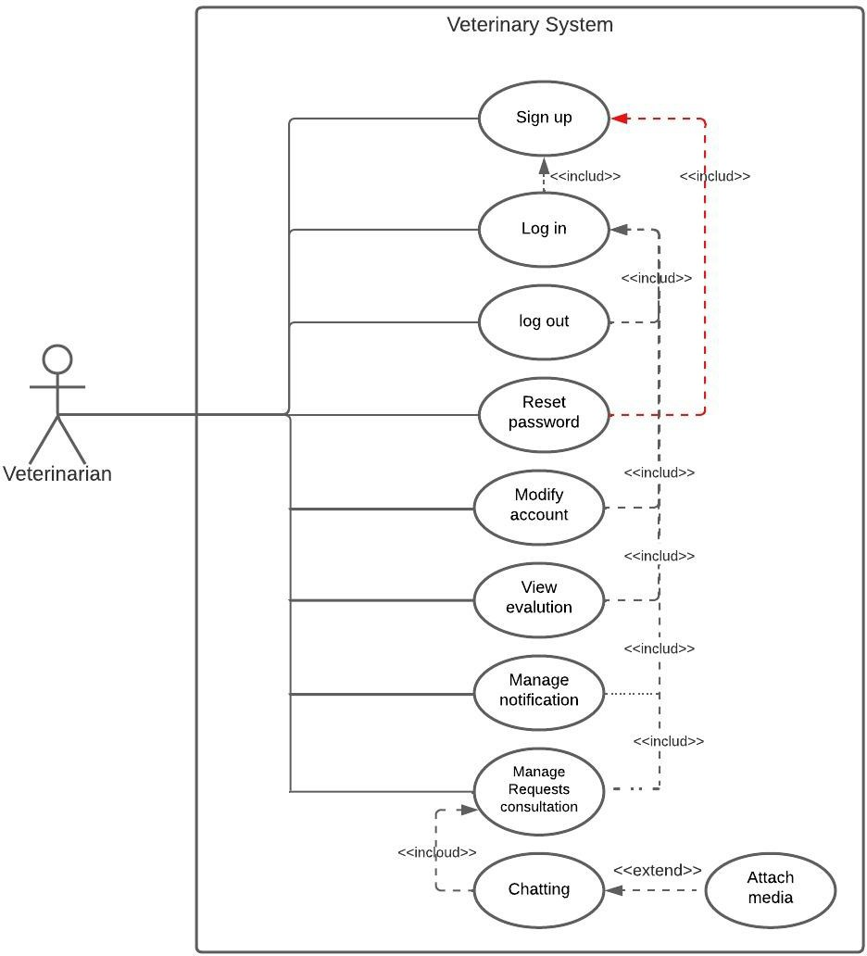

*Figure 4-2: Use case diagram for veterinarian*

##### Use case diagram for clinic

The figure shows the steps taken by the clinic, starting from registering in the system, entering it, managing the clinic's account, the ability to reset the password if needed, as well as managing appointment requests and reservations, viewing evaluations, and managing notifications.

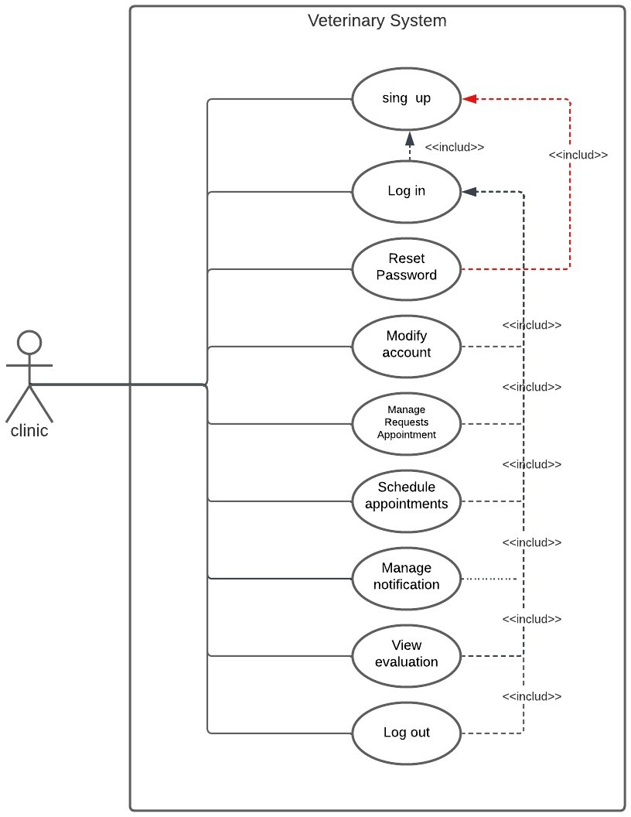

*Figure 4-3: Use case diagram for clinic*

##### Use case diagram for client

The figure shows the steps taken by clint, starting from registering in the system and entering the system, and the possibility of resetting the password in case he forgot it, and managing his account, where he can modify the name and e-mail, and also, he can start the conversation and attach the media, and he can also book and amend appointments and allow him Browsing the application and viewing or adding ratings and managing notifications, and he can also log out of the application**.**

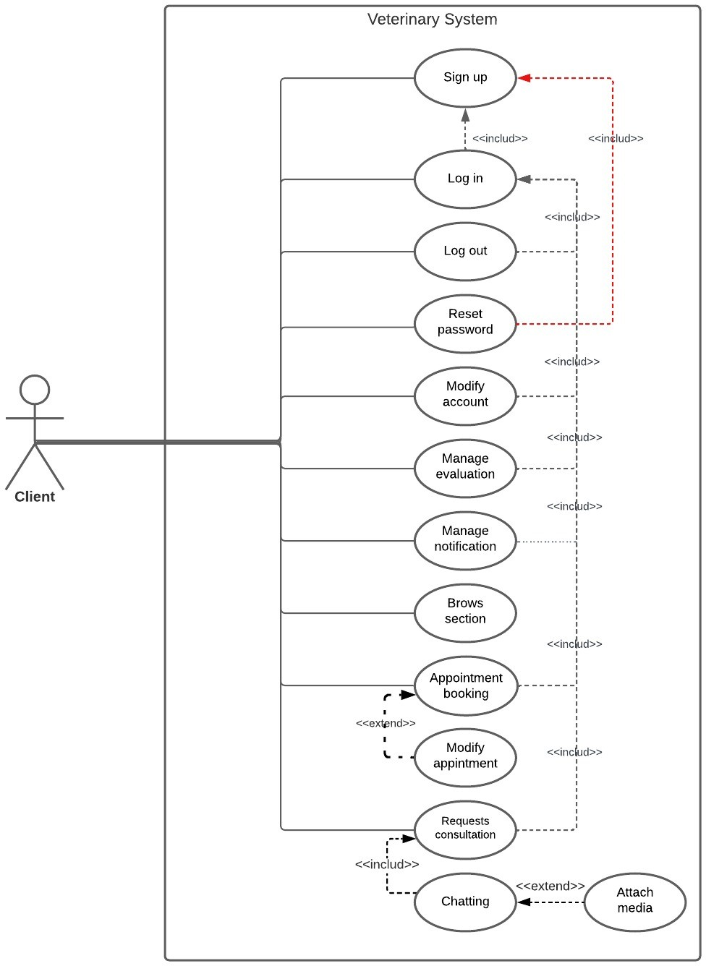

*Figure 4-4: Use case diagram for clint*

#### Interaction Models (System Use Case)

An interaction model describes how users interact with individual components of an application to trigger this action or feedback. [8]

###### Log in

In this section, an explanation of how the system allows all Actors to log in to the application by entering the required data and verifying it through the database.

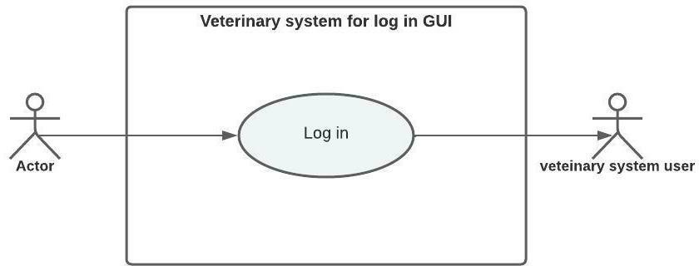

*Figure 4-5: system use case for log in*

|  |  |
| --- | --- |
| **Interaction models: log in** | |
| **Actor** | Admin, clint, clinic, Veterinarian |
| **Description** | The actor enters his information Then the validity of the data is verified through the database after that a message is sent if the entered data is wrong, or the entry process succeeds if the entered data is correct. |
| **Data** | Emil, password |
| **Stimulus** | The actor wants to log in to the application |
| **Response** | Log in failure message:" The data entered is incorrect, try again" or Log in success message:" Logged in successfully". |
| **Comments** | Any actor can log in on the application |

*Table 4-1: Interaction models: log in*

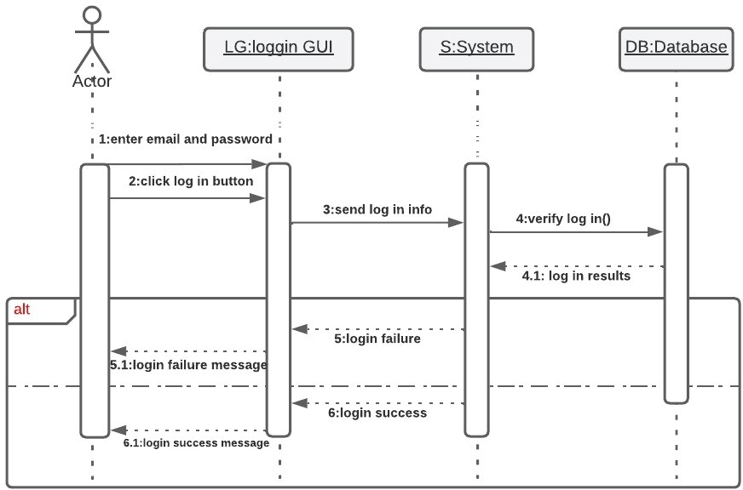

*Figure 4-6: sequence diagram for log in*

###### Reset password

In this section, explain how the system allows all actors to restore the account when the password is forgotten by setting a new password.

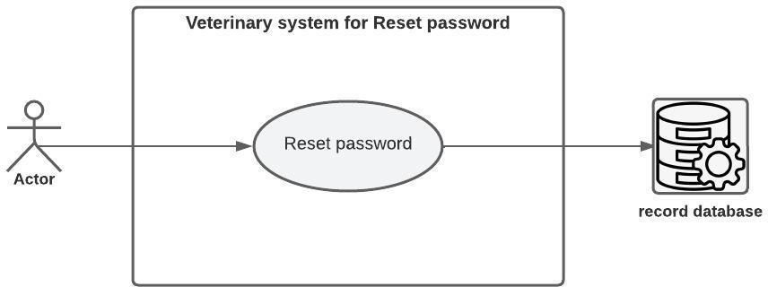

*Figure 4-7: system use case for Reset password*

|  |  |
| --- | --- |
| **Interaction models: Reset Password** | |
| **Actor** | Admin, clint, clinic, Veterinarian |
| **Description** | The actors enter the email previously registered in the system and it is verified through the database, then enter the code sent to email, and a new password is set if the entered code is correct or a message is not success. |
| **Data** | Emil |
| **Stimulus** | Actors wants to reset a new password and recover his account. |
| **Response** | Data verification success message 'Email verified, set a new password'  Data verification failed message 'The entered code is incorrect' |
| **Comments** | Any actor registered in the system can reset a new password if the password is forgotten. |

*Table 4-2: Interaction models: Reset password*

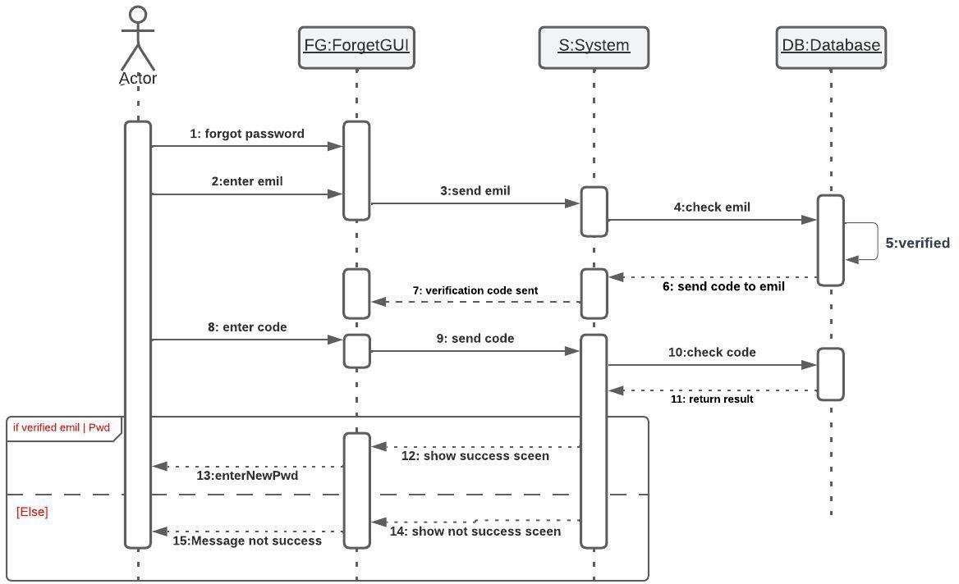

*Figure 4-8: sequence diagram for Reset password*

###### Request Consultation

In this section, an explanation of how to request a consultation for the client and store the consultation request in the database.

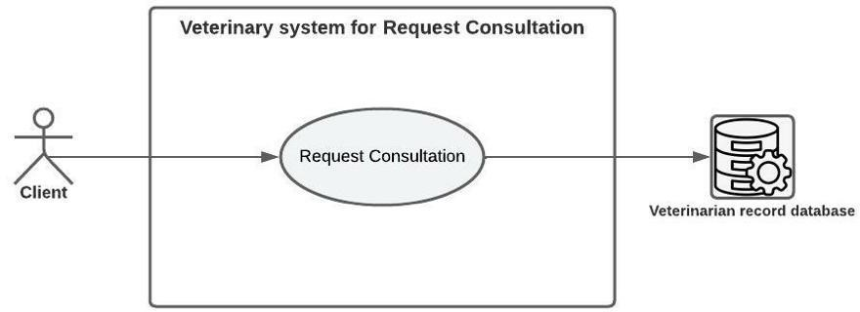

*Figure 4-9: system use case for request consultation*

|  |  |
| --- | --- |
| **Interaction Models: Request Consultation** | |
| **Actor** | Client, veterinarians record database |
| **Description** | The client can browse veterinarians, send a consultation request to an available veterinarian, and store the consultation information in the veterinarians record database. |
| **Data** | Name animal, Type animal, D**etails** |
| **Stimulus** | Send a consultation request from the client to the veterinarian. |
| **Response** | Notification message ' wait there will be a reply shortly' |
| **Comments** | Any client can request a consultation from any veterinarian after logging in to the veterinary app |

*Table 4-3: Interaction models: request consultation*

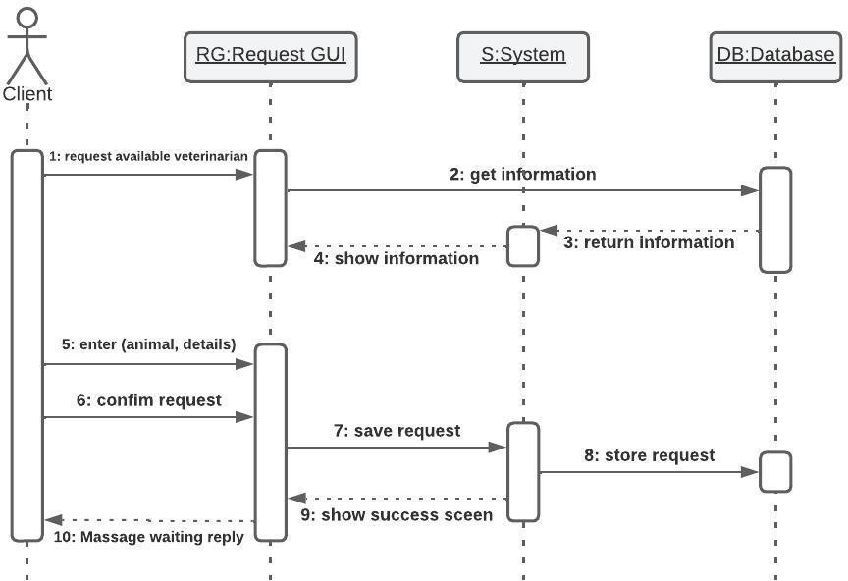

*Figure 4-10: sequence diagram for request consultation*

* + 1. Appointment Booking

In this section, an explanation of how to book an appointment for the client and ointment booking in the clinic database.

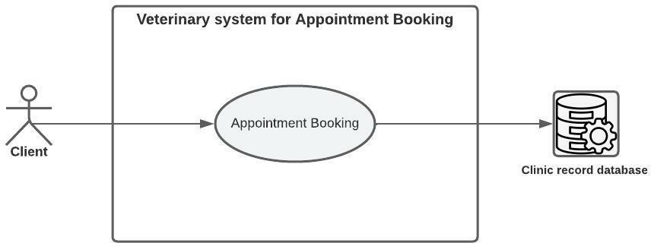

*Figure 4-11: system use case for Appointment*

|  |  |
| --- | --- |
| **Interaction Models: Appointment Booking** | |
| **Actor** | Clint, clinic |
| **Description** | The client can book an appointment from the application after logging in, and the booking information is entered into the clinic's database. |
| **Data** | Date and time of booking. |
| **Stimulus** | The clint want to book an appointment. |
| **Response** | Confirmation message: "Booking done successfully ". Or an error message: "Appointment not available". |
| **Comments** | any client Can book an appointment after registering in the veterinary system. |

*Table 4-4: Interaction models: Appointment*

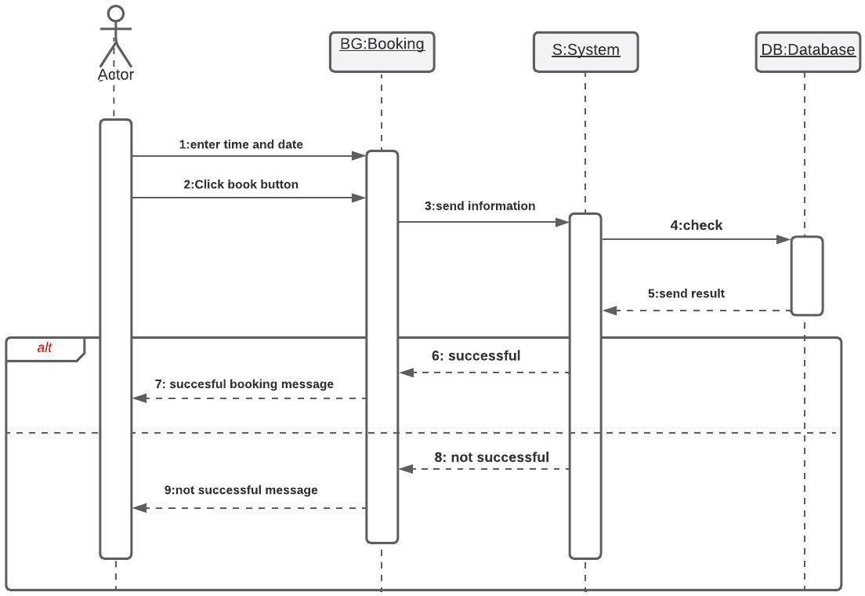

*Figure 4-12: sequence diagram for Appointment Booking*

##### Class Diagram

Class diagram describes the attributes and operations of a class and also the constraints imposed on the system by showing the classes, their attributes, and the relationships among the classes. [9]

##### Class Diagram for Veterinary System

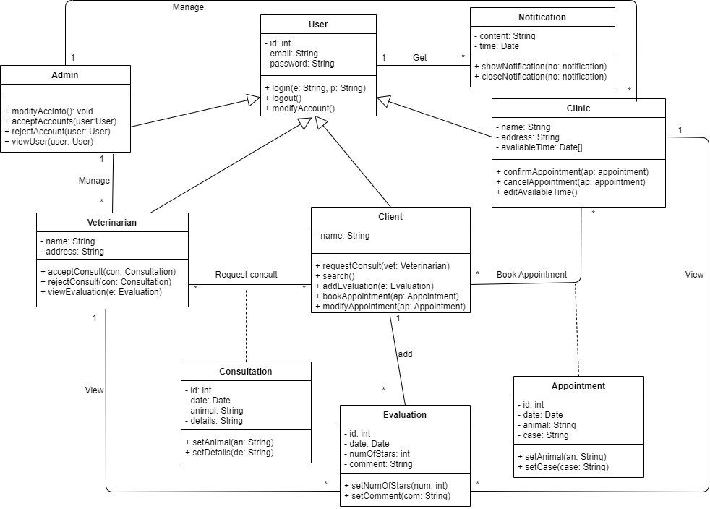

*Figure 4-13:class diagram for veterinary system*

##### ER Diagram

is a graphical representation that depicts relationships among people, objects, places, concepts or events within an information technology (IT) system. [11]

###### ER Diagram for Veterinary System

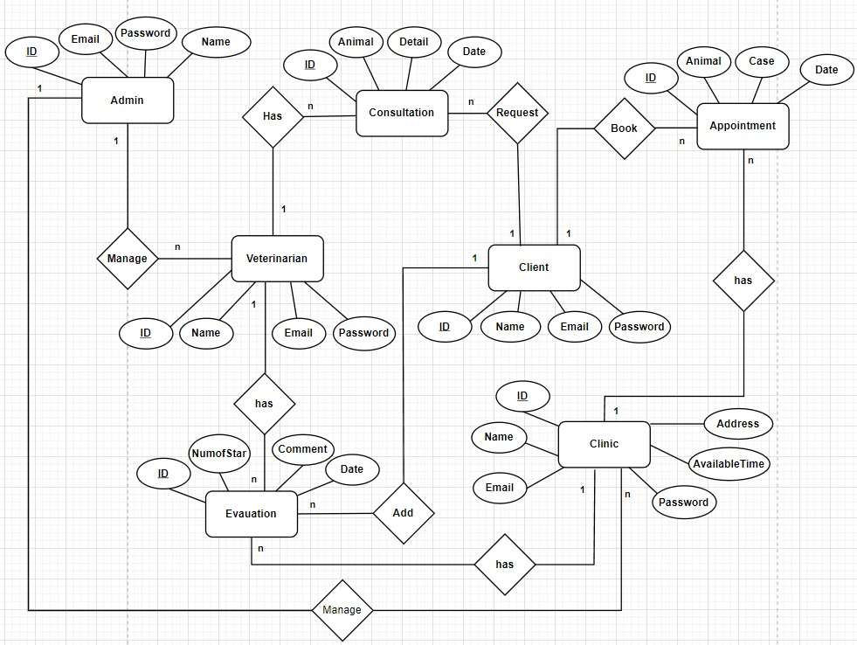

*Figure 4-14: ER diagram for Veterinary System*

##### Database Schema

A database schema is the skeleton structure that represents the logical view of the entire database, outlines how key elements in a relational database, such as tables and records, are organized and connected with each other. It formulates all the constraints that are to be applied on the data [10]

###### Database Schema for Veterinary System

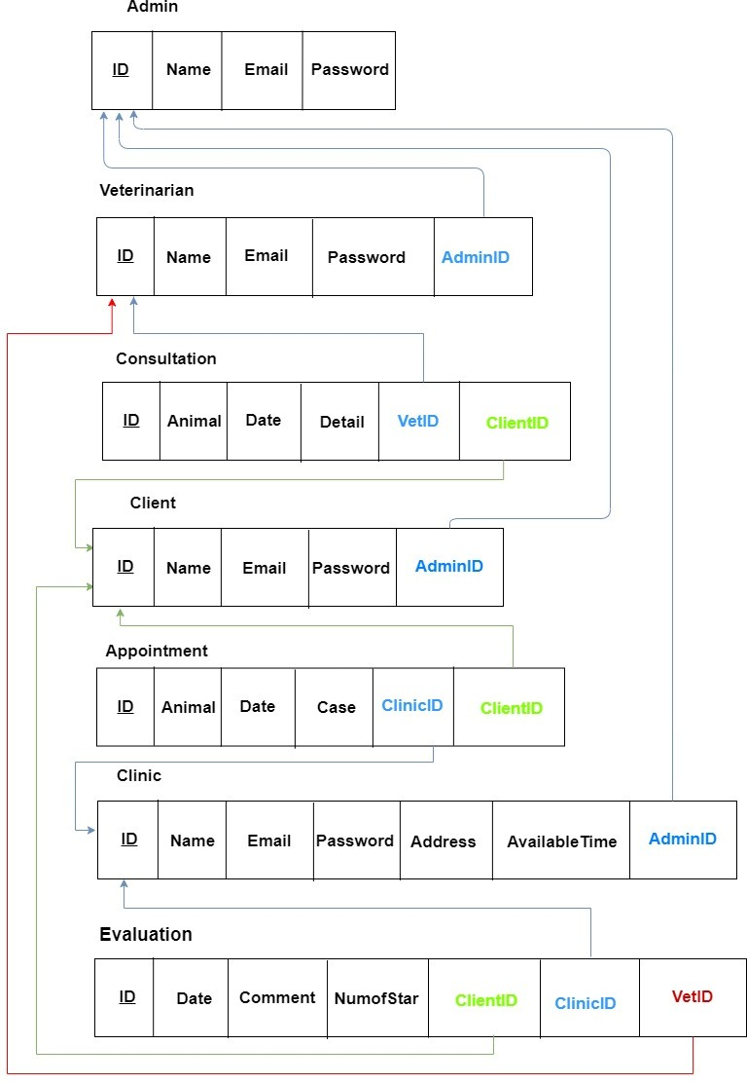

*Figure 4-15: Database S**chema for Veterinary System*

##### Conclusion

At this point, the system is illustrated using UML diagrams. (Use case diagram for each actor, Sequence diagram to log in, to request an appointment, and to request a consultation, Class diagram) and an ER diagram and database schema to illustrate the database Which makes the system clear and ready for actual implementation in the next phase.

# Chapter 5

Summary

## Summary

The idea of the project was to design a veterinary application. This project contains services that meet the needs of those interested in the category of animals or their breeders, as shown in this project. The importance of our identification of the project requirements is to help us in executing the project by following the functional and non-functional requirements and following up the system analysis.

The methods of the systems have changed dramatically over the past years, in terms of how to find veterinary consultation and evaluate the quality of this consultation, these things usually different from one application to another. In order to improve the process of communication with the veterinarian in applications that care for animals.

And because the large number of people interested in animals and their needs that are constantly changing, we seek, in the "Tarahum App", to provide what is commensurate with these needs, because technology has become a part of society that spends most of the time using it. Therefore, it is necessary to use this technology to facilitate the process of finding a veterinarian or a veterinary clinic for those interested in the category of animals through a veterinary consultation or booking an appointment at the veterinary clinic to save time and effort. This project contributes to the ease of access to a veterinarian through the World Wide Web. Once you have an account on the application, we aspire to create a compassion application to achieve the goal of facilitating the arrival of animals with animals to the veterinarian. The project also adopts the waterfall model, which provides an organized approach through successive stages that are easy to understand and interpret. Dart has also been adopted as the primary language for writing applications using Flutter.

## References

1. *Waterfall Methodology in Project Management, INFINITY ,By* [*Winston W. Royce*](http://www-scf.usc.edu/~csci201/lectures/Lecture11/royce1970.pdf)*, Online at: [* [*https://startinfinity.com/project-management-methodologies/waterfall*](https://startinfinity.com/project-management-methodologies/waterfall) *]*
2. *Zoolker , by Rowyda Al-rashedy , created at 2021, Online at:*

***[*** [*https://www.zoolker.com/*](https://www.zoolker.com/) *]*

1. *PawSquad, by Diwaker Singh and Radu Georgescu, created at 2015 Online at: [* [*https://pawsquad.com/*](https://pawsquad.com/) *]*
2. *PatCoach, by Alvaro Jimenez and Brock Weatherup and David Martin and Fernando Pascua García, created at 2014, Online at:* ***[*** [*https://www.petcoach.co/*](https://www.petcoach.co/) *]*
3. *VerCode, by Ahmed El-Badawy, created at 2018,Online at: [* [*https://vetcode.net/*](https://vetcode.net/) *]*
4. *Creating Your Software Requirements, Keene Systems , by Lance Keene, created at 2018, Online at: [* [*https://www.keenesystems.com/blog/creating-your-software-*](https://www.keenesystems.com/blog/creating-your-software-requirements)[*requirements*](https://www.keenesystems.com/blog/creating-your-software-requirements) *]*
5. *The Unified Modeling Language, by Kirill Fakhroutdinov, created at 2009, Online at: [* [*https://www.uml-diagrams.org/*](https://www.uml-diagrams.org/) *]*
6. *How To Design Interaction Models In An Application? , Netguru, by Maciej Dyjak, created at 2012, Online at: [* [*https://www.netguru.com/blog/how-to-design-interaction-*](https://www.netguru.com/blog/how-to-design-interaction-models-in-application)[*models-in-application*](https://www.netguru.com/blog/how-to-design-interaction-models-in-application) *]*
7. *Suriya, S., and S. Nivetha. "Design of UML Diagrams for WEBMED-Healthcare Service System Services." EAI Endorsed Transactions on e-Learning 8.1 (2023).*
8. *What is a database schema? , Fivetran, by Charles Wang, created at 2022, Online at: [* [*https://www.fivetran.com/blog/what-is-a-database-schema*](https://www.fivetran.com/blog/what-is-a-database-schema) *]*
9. *Entity Relationship diagram (ERD) , Techtarget , by Jacqueline Biscobing, created at 2019, Online at: [*[*https://www.techtarget.com/searchdatamanagement/definition/entity-relationship-*](https://www.techtarget.com/searchdatamanagement/definition/entity-relationship-diagram-ERD?amp=1)[*diagram-ERD?amp=1*](https://www.techtarget.com/searchdatamanagement/definition/entity-relationship-diagram-ERD?amp=1)*]*